BUBBLEFISH
Post-Phase 3 Fixes
Community Edition & Enterprise Edition
Version 2.0 | March 2026 | CONFIDENTIAL
Created by Shawn Sammartano

Confidential – No Redistribution.
This document contains confidential and proprietary information about the BubbleFish project owned by Shawn Sammartano. It is provided solely for review by the intended recipient. You may not copy, share, or redistribute this document, in whole or in part, without prior written permission from

Issue 2: Deep Analysis — What's Broken, What Will Break, What Needs to Change
Let me go layer by layer: current bugs still live, structural design risks, and Build Plan changes required.
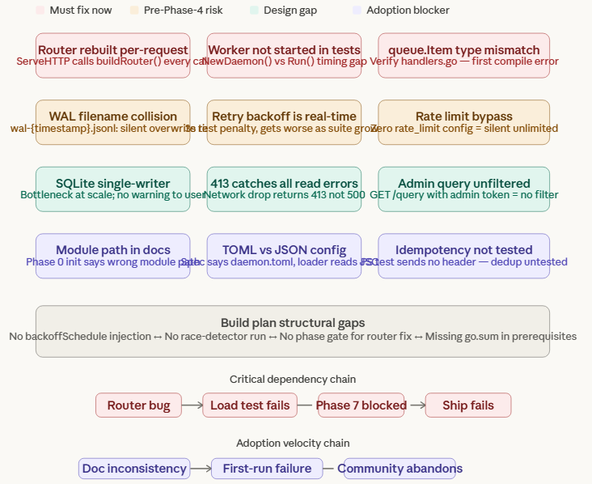

🔴 Must Fix Before Phase 4
Bug #4 — Router rebuilt on every HTTP request
This is the most dangerous active bug. ServeHTTP calls buildRouter() on every single request — the chi router, all middleware, all route registrations, rebuilt from scratch for every POST. This will not surface in Phase 3 manual testing because you're sending maybe 5 test requests. It will obliterate your Phase 7 load test at 1000 concurrent requests. A router construction allocates memory, registers closures, and is never designed to run on a hot path. Fix: build the router once in NewDaemon() and store it as a struct field (d.router). ServeHTTP just calls d.router.ServeHTTP(w, r). This is a one-line fix in daemon.go and a one-line fix in handlers.go, but it needs to happen before load testing or any performance measurement is meaningful.
Bug #3 — Worker goroutine not started in test context
The acceptance criterion "Payload appears in SQLite after write" will pass in a running daemon but silently fail in unit tests that call ServeHTTP without calling Run(). As Phase 4 and 5 add more end-to-end tests that don't spin up a full daemon, you'll accumulate tests that either randomly fail or require artificial sleeps. The fix: expose a startWorkers() method, or add a helper to NewDaemon() that starts the worker if a flag is set. The test harness should be able to call daemon.StartForTest() which does Run() minus the signal handler and blocking wait.
Bug #1 — queue.Item type mismatch
This is the "if it got out of sync during edits" time bomb. Before you write a single line of Phase 4 code, run go build ./.... If it fails with a type mismatch on queue.Enqueue, that's this bug. Fix is trivial — replace queueItem{...} with queue.Item{...} in handlers.go — but it needs to be verified clean before you stack more code on top of it.

🟡 Pre-Phase-4 Fixes (Fix Before Phase 5 at the Latest)
Concern #3 — WAL filename collision
The spec calls out a WAL that "never loses data" as a core design promise. Right now, if Rotate() fires twice in the same second, the second call silently overwrites the first archived segment — gone, no error, no log. In a normal production run this is unlikely. But the Phase 7 load test hammers the system, and if maxBytes is set low in tests or rotation happens under concurrent pressure, this is exactly the kind of thing that produces intermittent data loss that's hell to diagnose. Fix: add an atomic.Int64 rotation counter (same approach used to fix the row ID issue in Phase 2) and name segments wal-{timestamp}-{n}.jsonl. One counter, always unique, zero coordination needed.
Concern #5 — Backoff schedule hardcoded at real wall-clock durations
Your test suite currently spends 3 seconds on a single retry test. Phase 4 adds 4 destination plugins, each with their own error and retry paths. By Phase 7 you're looking at 30+ seconds of artificial waiting in a test run, which degrades the feedback loop and makes developers skip running tests. Fix: make backoffSchedule injectable via WorkerConfig — BackoffSchedule []time.Duration. Tests pass []time.Duration{0, 0, 0}. Production keeps 1s, 2s, 4s. This is a 5-line change with massive payoff in every remaining phase.
Concern #5b — Rate limit bypass with zero config
A source config with no rate_limit block silently gets unlimited throughput with no log warning. In a community build, misconfiguration is the norm, not the exception. A user who accidentally omits the rate limit block — or who copies a template that doesn't include one — will bypass rate limiting entirely with no indication. Fix: at daemon startup (or build time), log a warning for any source with no rate limit configured: WARN: source "claude" has no rate_limit configured — unlimited throughput. Don't enforce a default limit (that's a breaking change), just make the silent behavior visible.

🟠 Design Gaps That Will Bite in Production
Concern #6 — 413 catches all read errors
The 413 response path relies on io.ReadAll returning an error, but MaxBytesReader isn't the only thing that can fail a read — a client that disconnects mid-send also causes a read error. Right now that disconnection returns 413 to... nobody, since the client is gone, but it's logged as an oversized payload. In high-traffic community deployments this will pollute your error metrics with false 413s, masking real size violations. Fix: check the error type. MaxBytesReader wraps its limit error in a specific type — use errors.As() to distinguish it from generic io.EOF or network errors.
Concern #7 — Idempotency acceptance test doesn't test idempotency
The Phase 3 acceptance criterion says "Duplicate idempotency_key returns 200 without re-writing" — but the PowerShell verification script never sends an Idempotency-Key header. The test passes but proves nothing. This matters because the idempotency layer is a safety net for retry storms. When a community user builds a client that retries aggressively on network hiccups, the idempotency store is what prevents duplicate entries. Fix: update the Phase 3 PowerShell test to send two identical requests with a matching Idempotency-Key header and verify the database count doesn't increase on the second call.
Concern #8 — Admin token query returns unfiltered data
This is a security design gap disguised as a minor edge case. The response filter is positioned in the product as a token optimization and data hygiene feature — "your AI clients only see what they need." But the filter only works when the request comes from a source API key. An admin token query bypasses it. In an enterprise deployment this becomes a data leakage vector: whoever holds the admin token can read unfiltered records including fields that were supposed to be stripped. For Community this is "probably fine" — but the Product Guide section on Response Filter is explicit about its purpose, and silent bypass violates the design contract. Fix: document the behavior explicitly in the spec and add a log warning when a query is served unfiltered due to admin-token auth.

🔵 Adoption Velocity Killers
These won't break your build. They will break your launch.
Module path inconsistency in the Build Plan
Phase 0 of the Build Plan says: go mod init github.com/shawnsammartano/bubblefish. Your actual repo is github.com/shawnsammartano-hub/BubbleFish. The Phase 2 bug log caught this as a fix during the build — but the Build Plan document itself still has the wrong path. Any community contributor who follows the Build Plan verbatim from Phase 0 will produce a module that fails to compile. The fix is one word in one document, but the consequence of not fixing it is every first-time contributor hitting a mysterious compile error on day one.
TOML vs JSON daemon config
The spec says ~/.bubblefish/daemon.toml. The code reads JSON. The Phase 7 release tag will have documentation that contradicts the runtime behavior. Fix: pick one (TOML is what the spec promises — it's consistent with source and destination configs) and make the code match. The BurntSushi/toml package is already a dependency from Phase 0.
go mod tidy not in the Phase 0 prerequisites
The prerequisites section installs Go and Git, then runs go mod init and go get. It never says go mod tidy. A contributor who follows the guide step-by-step will hit the exact error you hit today on first build. Add go mod tidy as the last step in the Phase 0 PowerShell scaffold block, and add it to the quality gate between every phase.
Version constant hardcoded in handlers.go
"0.3.0" will drift. By Phase 7 when you tag v1.0.0-community, the /api/status endpoint will report 0.3.0. Fix: inject version at build time via ldflags. The Makefile and Dockerfile already need to handle this for Phase 6 anyway — do it in the Phase 6 deliverables list.

